## ------------------PIR (Infrared) Sensor-------------

* What is a PIR Sensor?

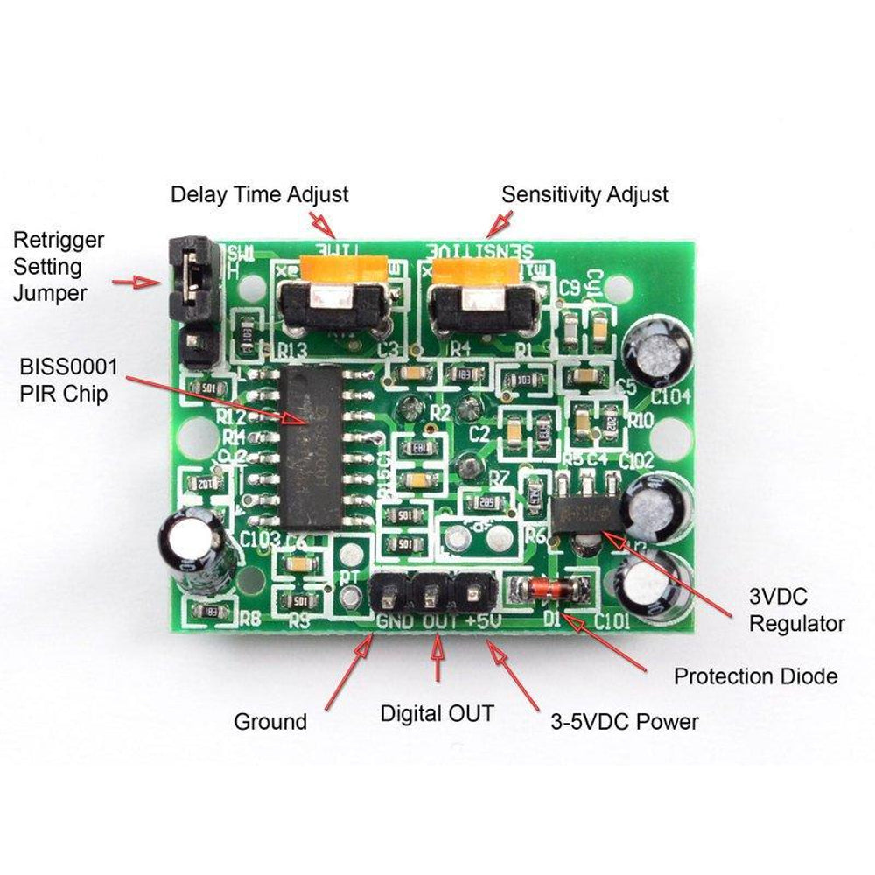

A **PIR (Passive Infrared) sensor** is an

Electronic device that detects motion by

Sensing infrared radiation emitted by

Objects, especially humans and animals.

It consists of a **pyroelectric sensor** and a

**Fresnel lens** to focus infrared signals.

When a moving object with heat, like a

Person, Enters the sensor’s range, it detects

Changes in Infrared levels and triggers an,

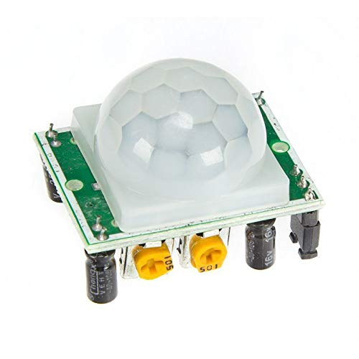

Output signal. PIR sensors are widely used

In **security systems, Automatic lighting,**

**And smart home applications**. They are

Energy-efficient, work without direct contact,

And have adjustable sensitivity and range,

Making them ideal for motion detection in

Various environments.

* Working Of PIR Sensor:

A **PIR (Passive Infrared) sensor** detects motion by sensing changes in infrared radiation emitted by objects, particularly humans and animals. It consists of a **pyroelectric sensor** that detects infrared heat and a **Fresnel lens** that focuses infrared signals onto the sensor. When a warm object moves within its detection range, the sensor registers a change in infrared levels and triggers an output signal. PIR sensors are commonly used in **security systems, automatic lighting, and motion-based alarms** due to their low power consumption and reliability. However, they cannot detect stationary objects and may be affected by temperature changes or environmental factors.